Create Cloudant DB

Deep Learning Fundus Image Analysis for Early Detection of Diabetic Retinopathy

Team ID: PNT2022TMID37928

* Create Service Instance
* Creating Service Credentials
* Launch Cloudant DB

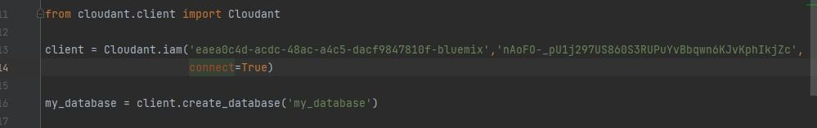

* Create Database

